Table of Contents

1，system setting 1

2，install what redmine enviromen need. 1

3,install apache and mysql 1

4，set mysql user 1

5,install php 4

6,create apache configure file and config phpmyadmin 4

8,create redmine database 8

9,install redmine 9

10，activate fcgi 11

11.install Apache and FastCGI module 12

12,create file storage path for redmine 12

13,install and start sendmail 13

14,create redmine vatual host 14

# 1，system setting

system version:centos6.5

installation setting:minimal

iptables:disabled

selinux:disabled

yum setting:network yum for initial source.

# 2，install what redmine enviromen need.

yum -y install zip unzip libyaml-devel zlib-devel curl-devel openssl-devel httpd-devel apr-devel apr-util-devel mysql-devel gcc ruby-devel gcc-c++ make postgresql-devel ImageMagick-devel sqlite-devel perl-LDAP mod_perl perl-Digest-SHA

this process need time a while,please wait.I suggest you can do something else,lol.

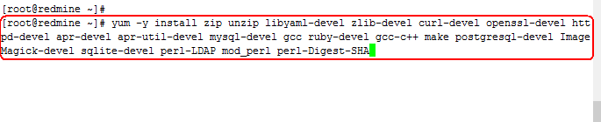

# 3,install apache and mysql

yum -y install httpd mysql mysql-server



chkconfig httpd on

chkconfig mysqld on

service httpd **start**

service mysqld **start**





# 4，set mysql user

Because we not have a password for the root account so you press Enter to skip.

Enter current password for root (enter for none): #输入当前mysql的root密码，因为yum套件关系，root密码为空，直接回车即可

**Select** Yes **to** **set** the password **for** the MySQL root account. #是否设置新的mysql root密码，选是

**Set** root password? [Y/n] y

Enter **and** confirm your password, remove the anonymous **user**, **select** Yes

Remove anonymous users? [Y/n] y #是否移除匿名用户，安全起见，选是

Allow remote login **to** MySQL **as** root account, **select** **No**.

Disallow root login remotely? [Y/n] n #是否关闭root远程登录，看你如何选择了，官网说否，如果不是外网服务器的话，开放也无所谓。

**Delete** the test database, **select** Yes

Remove test database **and** access **to** it? [Y/n] y #移除测试数据库

Reload privilege tables, **select** Yes #刷新权限配置信息

Reload privilege tables now? [Y/n] y

mysql_secure_installation

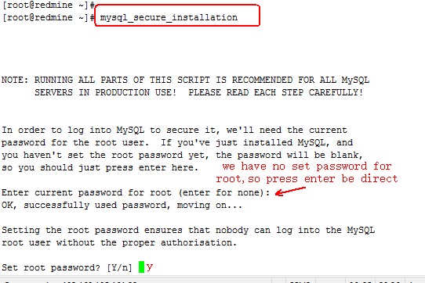

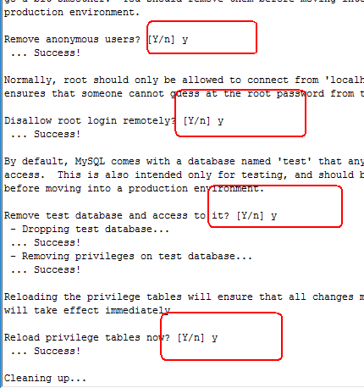

# 5,install php

yum -y install php php-mysql php-gd php-imap php-ldap php-mbstring php-odbc php-pear php-xml php-xmlrpc php-pecl-apc php-soap



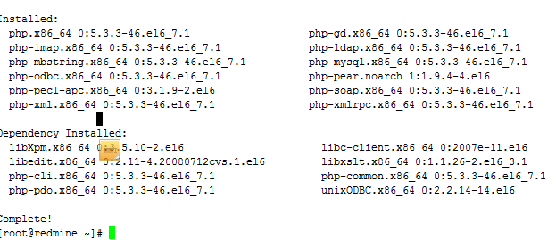





# 6,create apache configure file and config phpmyadmin

install phpmyadmin

rpm --import http://dag.wieers.com/rpm/packages/RPM-GPG-KEY.dag.txt

yum install http://pkgs.repoforge.org/rpmforge-release/rpmforge-release-0.5.3-1.el6.rf.x86_64.rpm

yum -y install phpmyadmin

vi /etc/httpd/conf.d/phpmyadmin.conf



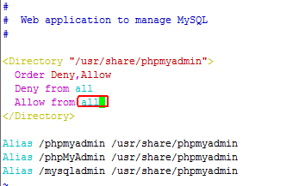

vi /usr/share/phpmyadmin/config.inc.php



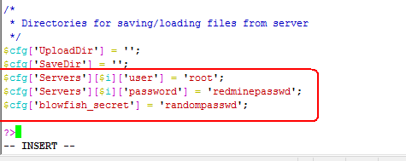

# 7,install ruby

[root@redmine ~]# \curl -L -k https://get.rvm.io | bash

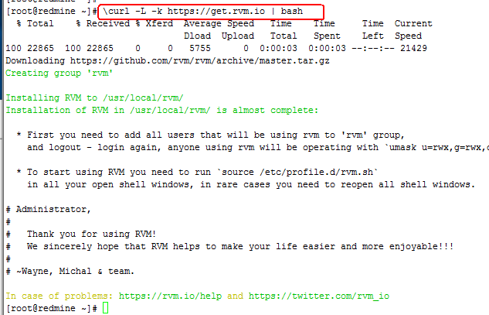

[root@redmine ~]# source /etc/profile.d/rvm.sh



rvm install 1.9.3 --verify-downloads 2



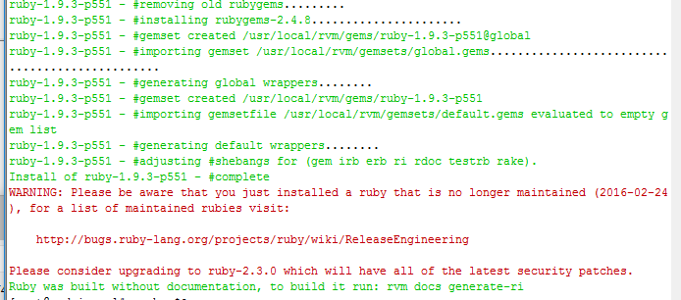

Complete

Check the ruby version

ruby -v

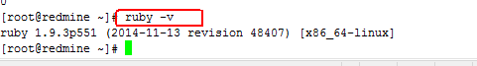

yum -y install rubygems

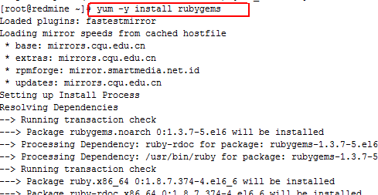

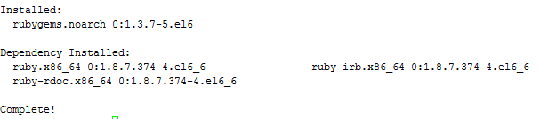

gem sources --add https://ruby.taobao.org/ --remove [https://rubygems.org/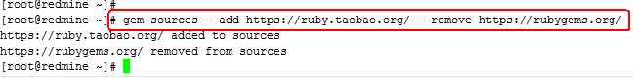](https://rubygems.org/)

gem install passenger

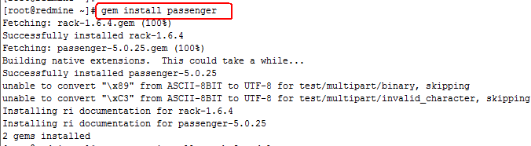

passenger-install-apache2-module

press enter enter enter

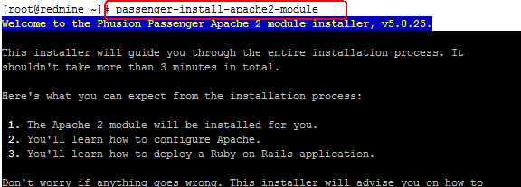

Copy this

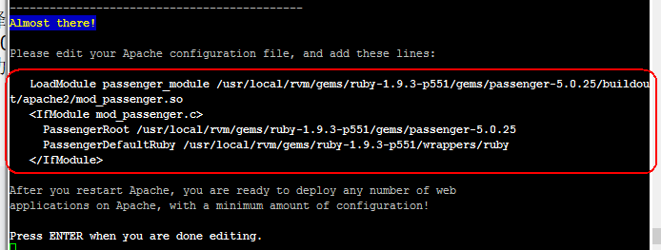



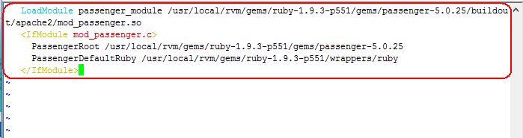

# 8,create redmine database



mysql> create database redmine_db character set utf8;

Query OK, 1 row affected (0.01 sec)

mysql> create user 'redmine_admin'@'localhost' identified by 'redminepassword';

Query OK, 0 rows affected (0.00 sec)

mysql> grant all privileges on redmine_db.* to 'redmine_admin'@'localhost';

Query OK, 0 rows affected (0.00 sec)

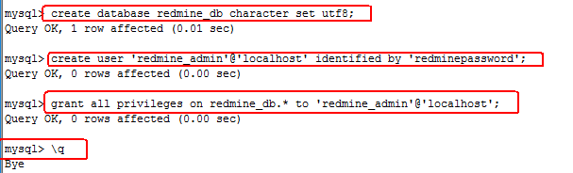

# 9,install redmine

Download redmine

[root@redmine ~]# wget http://www.redmine.org/releases/redmine-2.5.0.tar.gz

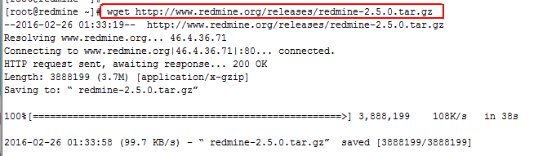

[root@redmine ~]# tar xf redmine-2.5.0.tar.gz

[root@redmine ~]# mv redmine-2.5.0 /var/www/redmine

[root@redmine ~]# cd /var/www/redmine/config

[root@redmine config]# cp database.yml.example database.yml

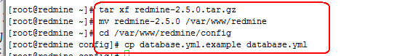

[root@redmine config]# vim database.yml



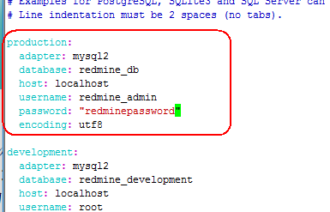

[root@redmine config]# gem install bundler

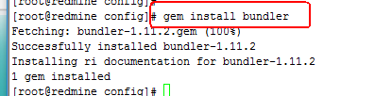

[root@redmine config]# bundle config 'mirror.https://rubygems.org' 'https://ruby.taobao.org'

[root@redmine config]# bundle install

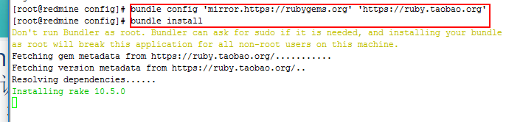

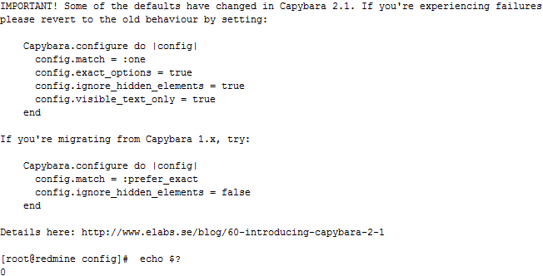

rake generate_secret_token



RAILS_ENV=production rake db:migrate

RAILS_ENV=production rake redmine:load_default_data



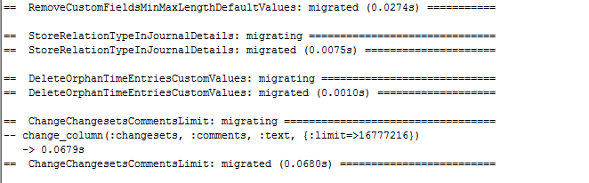



# 10，activate fcgi

cd /**var**/www/redmine/**public**

mkdir plugin_assets

cp dispatch.fcgi.example dispatch.fcgi

cp htaccess.fcgi.example .htaccess

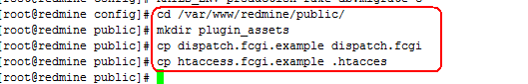

# 11.install Apache and FastCGI module

cd /**var**/www/

rpm --import https:*//fedoraproject.org/static/0608B895.txt*

wget http:*//dl.fedoraproject.org/pub/epel/6/x86_64/epel-release-6-8.noarch.rpm*

rpm -ivh epel-release-6-8.noarch.rpm

yum -y install mod_fcgid

rm -rf epel-release-6-8.noarch.rpm

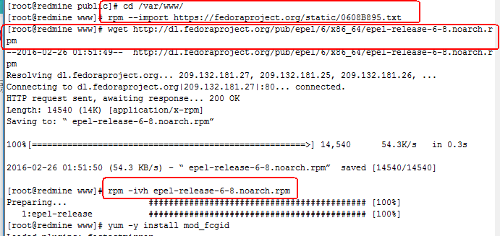



# 12,create file storage path for redmine

[root@redmine www]# mkdir -p /opt/redmine/files

[root@redmine www]# chown -R apache:apache /opt/redmine

[root@redmine www]# cd /var/www/redmine/config

[root@redmine config]# cp configuration.yml.example configuration.yml

[root@redmine config]# vim configuration.yml

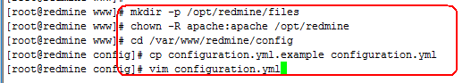

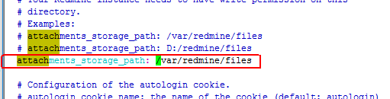

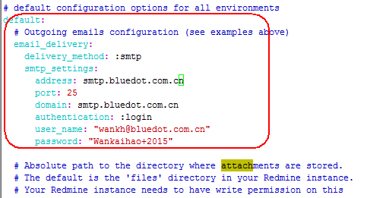

# 13,install and start sendmail

[root@redmine config]# yum install sendmail -y

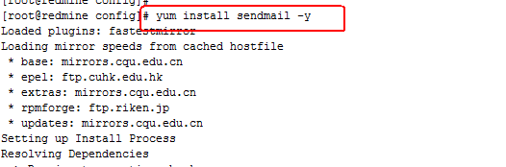

[root@redmine config]# /etc/init.d/sendmail start

[root@redmine config]# chkconfig sendmail on

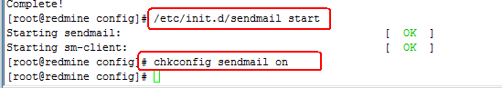

[root@redmine config]# yum provides mail

# 14,create redmine vatual host

[root@redmine www]# mkdir /var/www/redmine/public/logs



[root@redmine config]# vim /etc/httpd/conf.d/redmine.conf



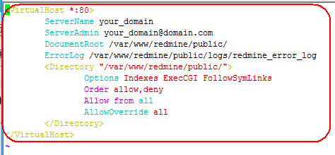

[root@redmine config]# cd /var/www

[root@redmine www]# chown -R apache:apache redmine

[root@redmine www]# chmod -R 755 redmine

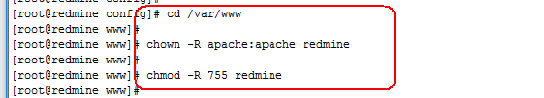

[root@redmine www]# /etc/init.d/httpd restart

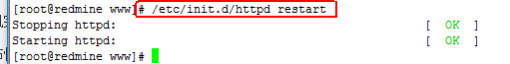

15,accese redmine

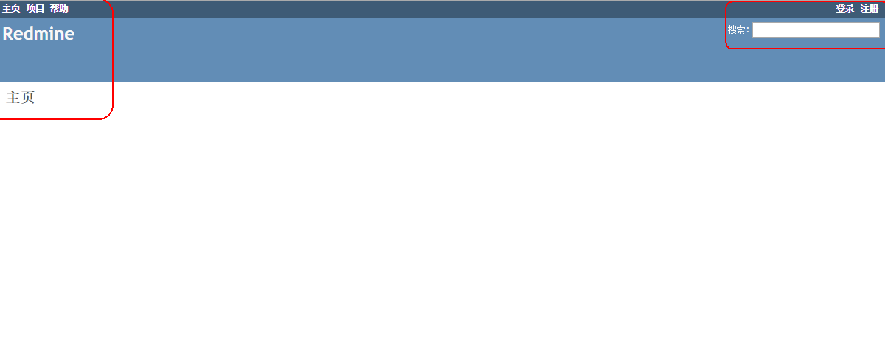

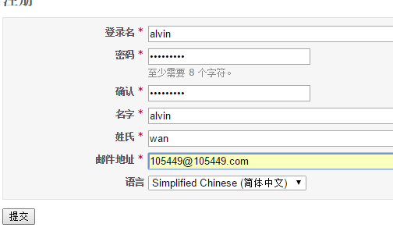

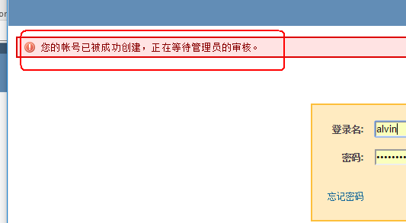

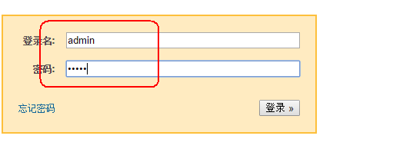

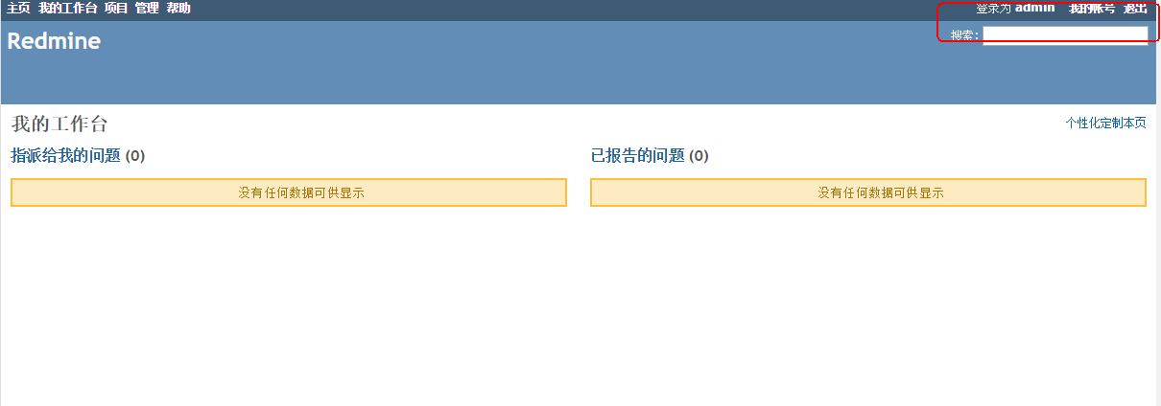

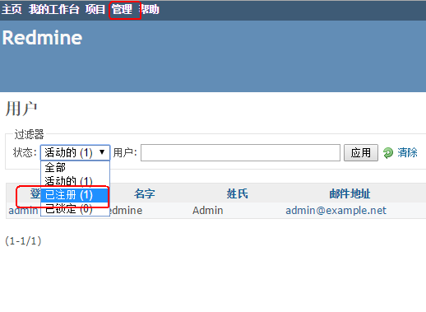

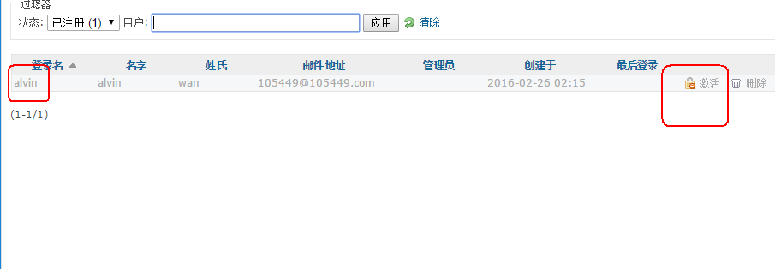

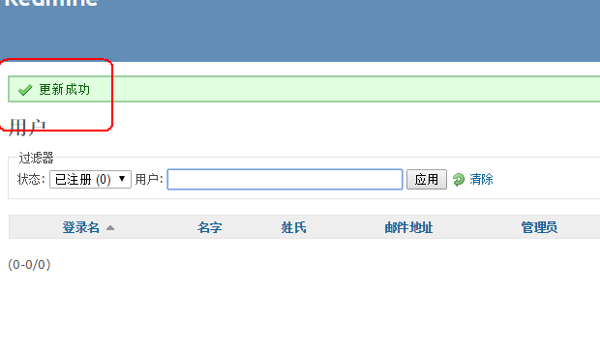

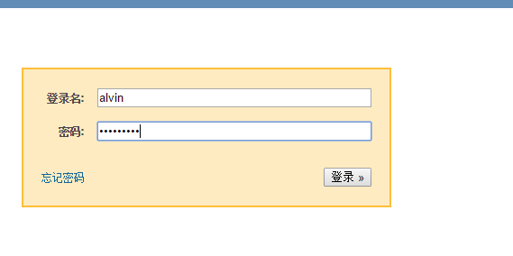

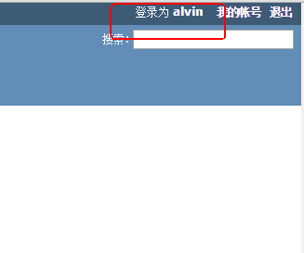

15,Mail setting

